

SIX WEEKS SUMMER TRAINING (CSE 443)
REPORT
On
PHP

Submitted by

Pritam Kumari
Registration No – 11404532
Programme Name – B.Tech CSE

Under the guidance of
Mr. Kushagra Singh

School of Computer Science & Engineering
Lovely Professional University, Phagwara
(June – July 2017)

DECLARATION

I hereby declare that I have completed my six weeks summer training at Allsoft Solutions, Jalandhar from 08th June 2017 to 20th July 2017 under the guidance of Mr. Kushagra Singh. I have declare that I have worked with full dedication during these six weeks of training and my learning outcomes fulfil the requirements of training for the award of degree of Bachelor of Technology in Computer Science and Engineering, Lovely Professional University, Phagwara.

Date: 29th July 2017 Pritam Kumari
11404532

Acknowledgement

There is always a sense of gratitude which one express towards others for their help and supervision in achieving the goals. This formal piece of acknowledgement is an attempt to express the feeling of gratitude towards people who helped me in successful completion of my training.
I would like to express my deep gratitude to Mr. Rohit, my training coordinator for his constant co-operation. He was always there with his competent guidance and valuable suggestion throughout the pursuance of this training session. I appreciate his kind guidance and motivational work towards us.
I would also like to place an appreciation for all the respondents and group members whose responses and coordination were of utmost importance for the project. I would like to thank them for supportive nature and also for their help in terms of knowledge sharing.
Above all no words can express my feelings to my parents, friends all those persons who supported me during my project. I am also thankful to all the respondents whose cooperation & support has helped me a lot in collecting necessary information.

Certificate
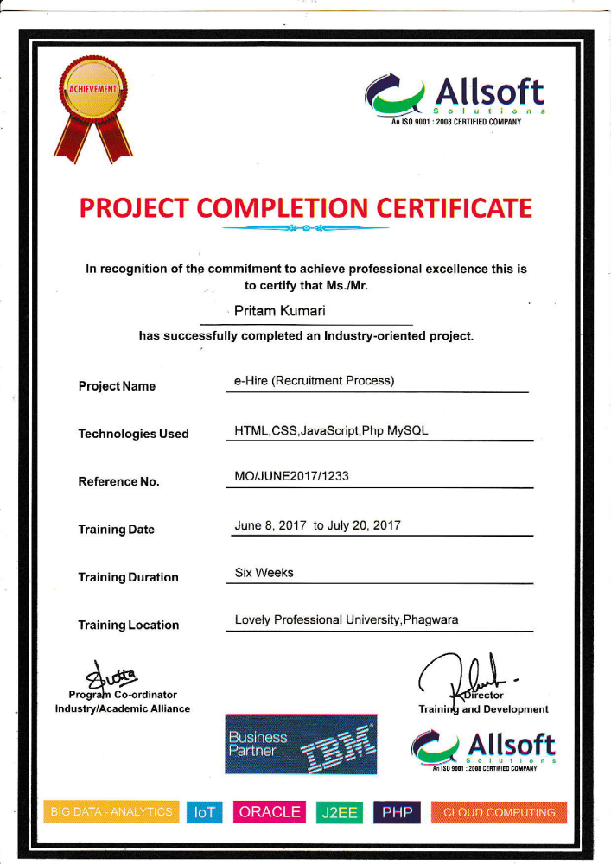

TABLE OF CONTENTS
Declaration.........................................................................................................................................................ii
Acknowledgement..............................................................................................................................................iii
Certificate...........................................................................................................................................................iv
Table of Contents...............................................................................................................................................v
1. Technology .....................................................................................................................................6
1.1. Introduction to PHP...........................................................................................................6
1.1.1. PHP Sessions.....................................................................................................6
1.1.2. Running PHP on CMD......................................................................................8
1.1.3. PHP and MySql... .............................................................................................8
1.1.4. Platform and Interfaces…..................................................................................9
1.1.5. WAMP .............................................................................................................10
1.1.6 WAMP Architecture ..........................................................................................10
1.1.7 PHP My Admin……. ........................................................................................11
1.2 HTML……. .......................................................................................................................11
1.3 CSS…….............................................................................................................................12
1.3.1 Advantages of CSS.............................................................................................12
1.4 Java Script.…......................................................................................................................13
1.4.1 Java Script vs Java..............................................................................................14
1.4.2 Java Script Language..........................................................................................15
1.4.3 Java Script Architecture......................................................................................16
2. Reason to choose this training............................................................................................................16
3. Data Flow Diagram.............................................................................................................................19
4. Learning Outcomes..............................................................................................................................19
5. Bibliography........................................................................................................................................20

Introduction to PHP

PHP started out as a small open source project that evolved as more and more people found out how useful it was. Rasmus Lerdorf unleashed the first version of PHP way back in 1994.There are some features of PHP which are following:
- PHP is a recursive acronym for "PHP: Hypertext Pre-processor".
- PHP is a server side scripting language that is embedded in HTML. It is used to manage dynamic content, databases, session tracking, even build entire e-commerce sites.
- It is integrated with a number of popular databases, including MySQL, PostgreSQL, Oracle, Sybase, Informix, and Microsoft SQL Server.
- PHP is pleasingly zippy in its execution, especially when compiled as an Apache module on the UNIX side. The MySQL server, once started, executes even very complex queries with huge result sets in record-setting time.
- PHP supports a large number of major protocols such as POP3, IMAP, and LDAP. PHP4 added support for Java and distributed object architectures (COM and CORBA), making n-tier development a possibility for the first time.
- PHP is forgiving: PHP language tries to be as forgiving as possible.
- PHP Syntax is C-Like.

PHP - Sessions

An alternative way to make data accessible across the various pages of an entire website is to use a PHP Session.
A session creates a file in a temporary directory on the server where registered session variables and their values are stored. This data will be available to all pages on the site during that visit.
The location of the temporary file is determined by a setting in the php.ini file called session.save_path. Before using any session variable make sure you have setup this path.
When a session is started following things happen −
- PHP first creates a unique identifier for that particular session which is a random string of 32 hexadecimal numbers such as 3c7foj34c3jj973hjkop2fc937e3443.
- A cookie called PHPSESSID is automatically sent to the user's computer to store unique session identification string.
- A file is automatically created on the server in the designated temporary directory and bears the name of the unique identifier prefixed by sess_ ie sess_3c7foj34c3jj973hjkop2fc937e3443.
When a PHP script wants to retrieve the value from a session variable, PHP automatically gets the unique session identifier string from the PHPSESSID cookie and then looks in its temporary directory for the file bearing that name and a validation can be done by comparing both values.
A session ends when the user loses the browser or after leaving the site, the server will terminate the session after a predetermined period of time, commonly 30 minutes duration.

Starting a PHP Session
A PHP session is easily started by making a call to the session_start() function.This function first checks if a session is already started and if none is started then it starts one. It is recommended to put the call to session_start() at the beginning of the page.
Session variables are stored in associative array called $_SESSION[]. These variables can be accessed during lifetime of a session.
The following example starts a session then register a variable called counter that is incremented each time the page is visited during the session.
Make use of isset() function to check if session variable is already set or not.

Running PHP Script from CMD

Yes you can run your PHP script on your command prompt. Assuming you have following content in test.php file
<?php
echo "Hello PHP!!!!!";
?>
Now run this script as command prompt as follows −
$ php test.php
It will produce the following result −
Hello PHP!!!!!

PHP & MySql

MySQL ( My S-Q-L, or "My sequel" ) is a relational database management system (RDBMS) which has more than 6 million installations. MySQL stands for "My Structured Query Language". The program runs as a server providing multi-user access to a number of databases.
The project's source code is available under terms of the GNU General Public License, as well as under a variety of proprietary agreements. MySQL is owned and sponsored by a single for-profit firm, the Swedish company MySQL AB, now a subsidiary of Sun Microsystems, which holds the copyright to most of the codebase.
MySQL is commonly used by free software projects which require a full-featured database management system, such as WordPress, phpBB and other software built on the LAMP software stack. It is also used in very high-scale World Wide Web products including Google and Facebook.

PHP combined with MySQL are cross-platform (you can develop in Windows and serve on a Unix platform)
- Connecting to MySQL database − Learn how to use PHP to open and close a MySQL database connection.
- Create MySQL Database Using PHP − This part explains how to create MySQL database and tables using
PHP.
- Delete MySQL Database Using PHP − This part explains how to delete MySQL database and tables using
PHP.
- Insert Data To MySQL Database − Once you have created your database and tables then you would like to
insert your data into created tables. This session will take you through real example on data insert.
- Retrieve Data From MySQL Database − Learn how to fetch records from MySQL database using PHP.
- Using Paging through PHP − This one explains how to show your query result into multiple pages and how
to create the navigation link.
- Updating Data Into MySQL Database − This part explains how to update existing records into MySQL
database using PHP.
- Deleting Data From MySQL Database − This part explains how to delete or purge existing records from
MySQL database using PHP.

Platforms and interfaces
The MySQL Administrator in Linux
MySQL is written in C and C++. MySQL works on many different system platforms, including AIX, BSDi, FreeBSD, HP-UX, i5/OS, Linux, Mac OS X, NetBSD, Novell NetWare, OpenBSD, OpenSolaris, eComStation, OS/2 Warp, QNX, IRIX, Solaris, Symbian, SunOS, SCO OpenServer, SCO UnixWare, Sanos, Tru64 and Microsoft Windows. A port of MySQL to OpenVMS is also available.
Libraries for accessing MySQL databases are available in all major programming languages with language-specific APIs. In addition, an ODBC interface called MyODBC allows additional programming languages that support the ODBC interface to communicate with a MySQL database, such as ASP or ColdFusion. The MySQL server and official libraries are mostly implemented in ANSI C/ANSI C++.

WAMP
WAMP Stands for "Windows, Apache, MySQL, and PHP." WAMP is a variation of LAMP for Windows systems and is often installed as software bundle (Apache, MySQL, and PHP). It is often used for web development and internal testing, but may also be used to serve live websites.
The most important part of the WAMP package is Apache (or "Apache HTTP Server") which is used run the web server within Windows. By running a local Apache web server on a Windows machine, a web developer can test webpages in a web browser without publishing them live on the Internet.
WAMP also includes MySQL and PHP, which are two of the most common technologies used for creating dynamic websites. MySQL is a high-speed database, while PHP is a scripting language that can be used to access data from the database. By installing these two components locally, a developer can build and test a dynamic website before publishing it to a public web server.
While Apache, MySQL, and PHP are open source components that can be installed individually, they are usually installed together. One popular package is called "WampServer," which provides a user-friendly way to install and configure the "AMP" components on Windows.

WAMP Architecture

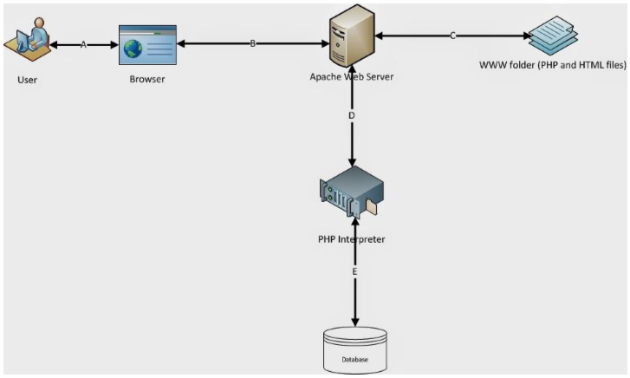

PHP MyAdmin

Php MyAdmin is one of the most popular applications for MySQL databases management. It is a free tool written in PHP. Through this software you can create, alter, drop, delete, import and export MySQL database tables. You can run MySQL queries, optimize, repair and check tables, change collation and execute other database management commands. All the SiteGround clients can manage their MySQL databases through the preinstalled Php MyAdmin software which is integrated in cPanel. Check our Php MyAdmin hosting for more details. In this tutorial we will show how to use Php MyAdmin and manage your MySQL databases through it.

The main Php MyAdmin features are as follows:
User-friendly web interface; Support for most MySQL functions like browse, drop, create, copy and alter databases, tables, views, fields and indexes, execute MySQL queries, manage stored procedures and functions; Import data from CSV and SQL files; Export data to various formats: CSV, SQL, XML, PDF, ISO/IEC 26300 - OpenDocument Text and Spreadsheet, Word, Excel, LATEX and others; Searching globally in a database or a subset of it.

HTML

HTML stands for Hyper Text Markup Language, which is the most widely used language on Web to develop web pages. HTML was created by Berners-Lee in late 1991 but "HTML 2.0" was the first standard HTML specification which was published in 1995. HTML 4.01 was a major version of HTML and it was published in late 1999. Though HTML 4.01 version is widely used but currently we are having HTML-5 version which is an extension to HTML 4.01, and this version was published in 2012.

<!DOCTYPE html>
<html>

<head>
<marquee> <title> Lovely Professional University </title> </marquee>
</head>

<body>
<h1>Here is a first heading.</h1>
<center><p>Here is a second paragraph of text.</p><br></center>
<hr />
<p>Here is a <u> third </u> paragraph of text.</p>
</body>
</html>

CSS

Cascading Style Sheets, fondly referred to as CSS, is a simple design language intended to simplify the process of making web pages presentable.
CSS handles the look and feel part of a web page. Using CSS, you can control the colour of the text, the style of fonts, the spacing between paragraphs, how columns are sized and laid out, what background images or colours are used, layout designs, and variations in display for different devices and screen sizes as well as a variety of other effects.
CSS is easy to learn and understand but it provides powerful control over the presentation of an HTML document. Most commonly, CSS is combined with the markup languages HTML or XHTML.

Advantages of CSS

- CSS saves time – If you can write CSS once and then reuse same sheet in multiple HTML pages. You can define a style for each HTML element and apply it to as many Web pages as you want.
- Pages load faster − If you are using CSS, you do not need to write HTML tag attributes every time. Just write one CSS rule of a tag and apply it to all the occurrences of that tag. So less code means faster download times.
- Easy maintenance − To make a global change, simply change the style, and all elements in all the web pages will be updated automatically.
- Superior styles to HTML − CSS has a much wider array of attributes than HTML, so you can give a far better look to your HTML page in comparison to HTML attributes.
- Multiple Device Compatibility − Style sheets allow content to be optimized for more than one type of device. By using the same HTML document, different versions of a website can be presented for handheld devices such as PDAs and cell phones or for printing.
- Global web standards − Now HTML attributes are being deprecated and it is being recommended to use CSS. So it’s a good idea to start using CSS in all the HTML pages to make them compatible to future browsers.
- Offline Browsing − CSS can store web applications locally with the help of an offline cache. Using of this, we can view offline websites. The cache also ensures faster loading and better overall performance of the website.
- Platform Independence − The Script offer consistent platform independence and can support latest browsers as well.
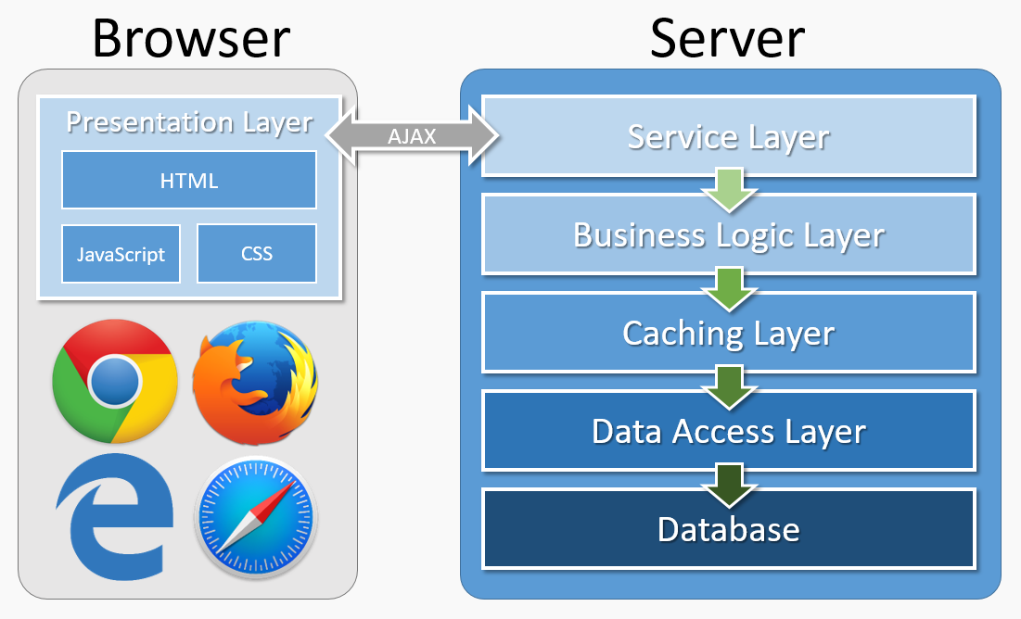

JAVA Script

JavaScript is most commonly used as a client side scripting language. This means that JavaScript code is written into an HTML page. When a user requests an HTML page with JavaScript in it, the script is sent to the browser and it's up to the browser to do something with it.
The fact that the script is in the HTML page means that your scripts can be seen and copied by whoever views your page. Nonetheless, to my mind this openness is a great advantage, because the flip side is that you can view, study and use any JavaScript you encounter on the WWW.
JavaScript can be used in other contexts than a Web browser. Netscape created server-side JavaScript as a CGI-language that can do roughly the same as Perl or ASP. There is no reason why JavaScript couldn’t be used to write real, complex programs. However, this site exclusively deals with the use of JavaScript in web browsers.
If you don’t have any programming experience at all it’s best to start with some gentle JavaScript examples that teach you the basics. It might be a good idea to buy Negrino & Smith, “JavaScript for the World Wide Web”, 4th edition, Peachpit Press, 2001. It contains some very useful examples and though it doesn’t treat advanced programming tricks, it will certainly help you get started. Of course this site also offers plenty of help.
I can also recommend Jeremy Keith, DOM Scripting: Web Design with JavaScript and the Document Object Model, 1st edition, Friends of Ed, 2005. This, too, is a book that doesn't delve too deeply into technology, but gives non-programmers such as graphic designers/CSS wizards an excellent overview of the most common uses of JavaScript - as well as the most common problems.

Java Script vs. Java

Although the names are much alike, JavaScript is primarily a scripting language for use within HTML pages, while Java is a real programming language that does quite different things from JavaScript. In addition Java is much harder to learn. It was developed by Sun for use in pretty much anything that needs some computing power.
JavaScript was developed by Brendan Eich, then working at Netscape, as a client side scripting language (even though there's no fundamental reason why it can't be used in a server side environment).
Originally the language was called Live Script, but when it was about to be released Java had become immensely popular (and slightly hypey). At the last possible moment Netscape changed the name of its scripting language to “JavaScript”. This was done purely for marketing reasons. Worse, Eich was ordered to "make it look like Java". This has given rise to the idea that JavaScript is a "dumbed-down" version of Java. Unfortunately there's not the slightest shred of truth in this story.
Java and JavaScript both descend from C and C++, but the languages (or rather, their ancestors) have gone in quite different directions. You can see them as distantly related cousins. Both are object oriented (though this is less important in JavaScript than in many other languages) and they share some syntax, but the differences are more important than the similarities.
If you are a C++ or Java programmer you will be surprised by some of JavaScript’s features. Since I don’t have any previous programming experience, the differences are not described on this site. The best you can do is buy David Flanagan, “JavaScript, the Definitive Guide”, 5th edition, O’Reilly, 2006. In this book the differences between C++/Java and JavaScript are clearly explained. I co–edited a few chapters of this book.

Java Script Language

JavaScript is not a programming language in strict sense. Instead, it is a scripting language because it uses the browser to do the dirty work. If you command an image to be replaced by another one, JavaScript tells the browser to go do it. Because the browser actually does the work, you only need to pull some strings by writing some relatively easy lines of code. That’s what makes JavaScript an easy language to start with.
But don’t be fooled by some beginner’s luck: JavaScript can be pretty difficult, too. First of all, despite its simple appearance it is a full-fledged programming language: it is possible to write quite complex programs in JavaScript. This is rarely necessary when dealing with web pages, but it is possible. This means that there are some complex programming structures that you’ll only understand after protracted studies.
Secondly, and more importantly, there are the browser differences. Though modern web browsers all support JavaScript, there is no sacred law that says they should support exactly the same JavaScript. A large part of this site is devoted to exploring and explaining these browser differences and finding ways to cope with them.
So basic JavaScript is easy to learn, but when you start writing advanced scripts browser differences (and occasionally syntactic problems) will creep up.

Java Script Architecture

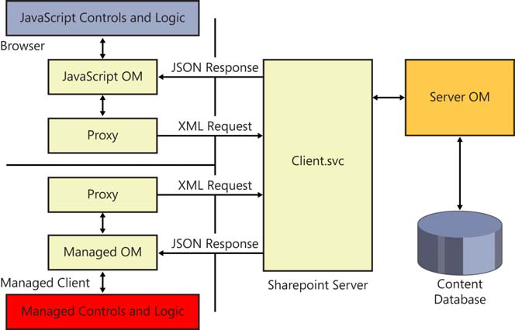

Reason to choose this training

The Internet industry has been revolutionizing numerous technologies for the betterment. Most web developers choose PHP to design their own website. The main reason is it is an open-source server-side scripting language that provides multifarious features. It is also an interpreted script language best suited for developing websites as per your preferences. Further, PHP is highly beneficial for its users since it is compatible with both Windows and Unix-based operating systems. It also enables the users to easily manage and upgrade their PHP based websites without any burdens. If you are looking to create a website then choose PHP to build exceptional quality websites and web applications effortlessly. Execution of a wonderful websites can easily be achieved with the support of expert PHP developers who have vast experience in the online industry.

- User – friendly
PHP is absolutely simple to comprehend than other programming languages. Since it is an easy and powerful language, it has been widely used for creating web based applications that requires utmost functionality with minimal coding. In addition, PHP based web applications are extremely secure as compared to applications of various other programming languages.

2. Flexibility
This is a one only language that provides maximum level of flexibility as compared to languages like Asp, .Net and etc. It is ideal for any users who look to extend the high-end programming language to exactly match the custom requirements of any businesses.
Moreover, it is open source software which allows the user to use any editor to write the code. It can also be combined with diverse libraries such as graphics and Extensible Markup language (XML) and etc.

3. Dynamic
It is an effective language enables you to develop lively websites which refresh automatically. Using PHP for creating websites may not require any updates manually for refreshing it. PHP web development includes a various interesting process that mesmerizes the users.

4. Cost Effective
PHP is being widely used by an extensive range of users for the past 2 years as it is economic for developing a website efficiently. Besides, it can easily be obtained free of charge from the internet. The users can also download the latest version for free of cost at any time. It is highly beneficial for web developers who strive to make a new entry in the online market.

5. Data Processing
Developing any website using PHP supports the user to include fast data processing features. It also helps to improve the website functions to a greater extent.

6. Open Source
PHP is universally recognized open source language which provides ultimate solutions for all website development needs. The reason behind the success of this high end language is, it is totally free and simple to use.

7. High Performance
PHP is a unique language that completely improves speed of development, rather increasing the speed of execution. It operates on a conventional web stack. PHP makes full use of Apache web server. Likewise, PHP applications utilize Apache web server as well as the MySQL database.

8. Cross Platform
Now, it is quite easy to create cross-platform applications with PHP since it works amazing on UNIX, LINUX and Windows platforms. It is developed in such a way that it interfaces with Apace and MYSQL. If you are interested to develop a cross platform application, PHP is the right choice.

9. Prominent in CMS
Any websites that has been developed from PHP are fully customized and assists the programmers to develop websites as per their clients’ preferences.

10. Embedding Qualities
One of the superior qualities of PHP language is that it can easily be embedded into HTML within a very few steps. This is an exemplary language supports web programmers to convert an existent static website into a whole new active one.

11. Extensions
Being a flexible and innovative language, it provides many numbers of extensions. The output of this language is fully significant and helps the users to determine their return on investment.

12. Instant
This is considered as a fast and instant language which caters quick turnaround time. By employing a well experienced PHP developer, you can obtain a prompt solution that you want to achieve for a very long time. These are some of the main reasons why all the web developers choose PHP over other languages for creating an unimaginable PHP web development projects.

Data Flow Diagram

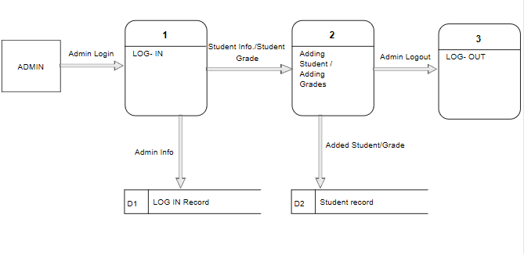

LEARNING OUTCOMES

I have learnt the difference between PHP and HTML. I also came to know the way and reasons to integrate Php with many databases MYSQL, SQL server and many more to enhance the working of the website. This training helped me in learning about various techniques like bootstrap and its advantages. I have learnt about WAMP, the software which provides a platform to work on the website using Php.

BIBLIOGRAPHY

- www.cmcltd.com
- Wikipedia.org/wiki
- www.scribd.com
- *Complete Reference to JAVA2
- Sun Microsystems and Cmc study material
- www.exforsys.com/tutorials/j2ee
- www.javatpoint.com

